BBMA ALERTS FOR DASHBOARD.
I hope I’m not demanding too much Swingman. Having worked a little with programmers before, I understand how important it is for you guys that the requirements be as detailed as possible. To this end I will provide attached annotated pictures as well.
Terminologies I will use in explaining the alerts;
MAHI is MA10 & MA5 high.
MALO is MA10 & MA5 low.
I’m only interested in the re-entry alerts of BBMA and I hope that this can be achieved through the framework that already exist within the dashboard or with a little adjustment. This happens only after two conditions:
- After a CSDC (Candlestick direction confirmed). That is a Candlestick that closes below moving average low (MALO) and Mid BB & vice versa.
For initial alert
Let’s assume we have a bullish CSDC (current candlestick closes above moving average high (MAHI) and Mid BB) the dashboard should indicate an alert message such as “Bullish CSDC H4”. (This was indicated in the previous dashboard by both the round arrow for MAHI touch and a straight arrow for a bound touch).
For reentry alert.
Now I would suggest that if within the same timeframe should price touch opposite moving averages (MALO) within the next 7 candles the dashboard should provide an alert “Bullish CSDC reentry H4”. The same should be true for a sell.
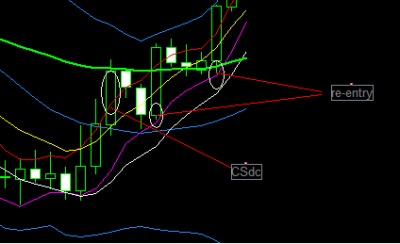
NB: Kindly ignore the green large line (EMA 50) in the above picture.
- After a momentum candlestick also known as CSM. This is a Candle stick that closes below the lower BB or above the upper BB.

For initial alert
Let’s assume we have a bullish CSM (current candlestick closes above top BB) the dashboard should indicate an alert message such as “Bullish CSM H4”. (This was indicated in the previous dashboard by a straight arrow appearing for band touch).

For reentry alert.
Now I would suggest that if within the same timeframe should price touch the (MALO) moving average low within the next 7 candles the dashboard should provide an alert “Bullish CSM reentry H4”. The same should be true for a sell.
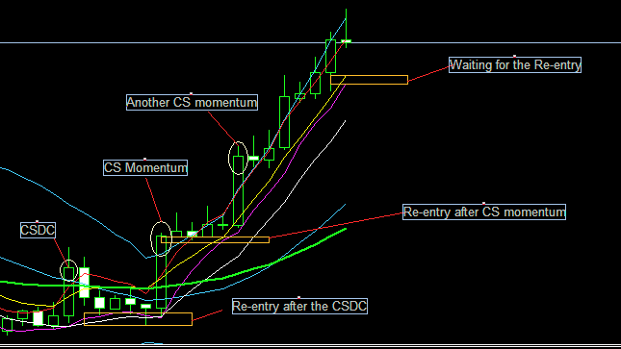
NB: Kindly ignore the green large line (EMA 50) in the above picture.

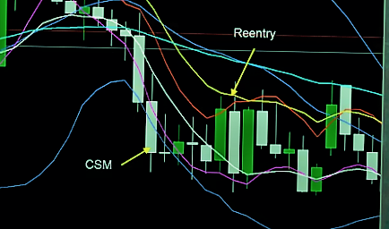
Another picture illustration of CSM reentry, this time a sell.

